Tabu Search Algorithm for Codebook Generation in Vector Quantization
PASI FRANTI, JUHA KIVIJÄRVI and OLLI NEVALAINEN
Pattern Recognition, Vol. 31, No. 8, pp. 1139-1148, 1998
Abstract
The key question is the definition of neighboring solution.
- Introduction
Tabu search includes the following potential improvements:
• The new solution is chosen among several candidates.
• The search is allowed to make suboptimal moves.
• The use of tabu list prevents local loops.

In the present paper, a new tabu search algorithm for the codebook generation problem with the following ideas:
• Distance weighted algorithm for modifying the partition.
• Codebook-based problem setup instead of partitioning-based.
• Inclusion of GLA iterations.
• Approximate tabu matching criterion.
- Background
- Nearest neighbor condition
- Centroid condition
- Generalized Lloyd Algorithm (GLA)
- Simulated Annealing
- Tabu Search Algorithm
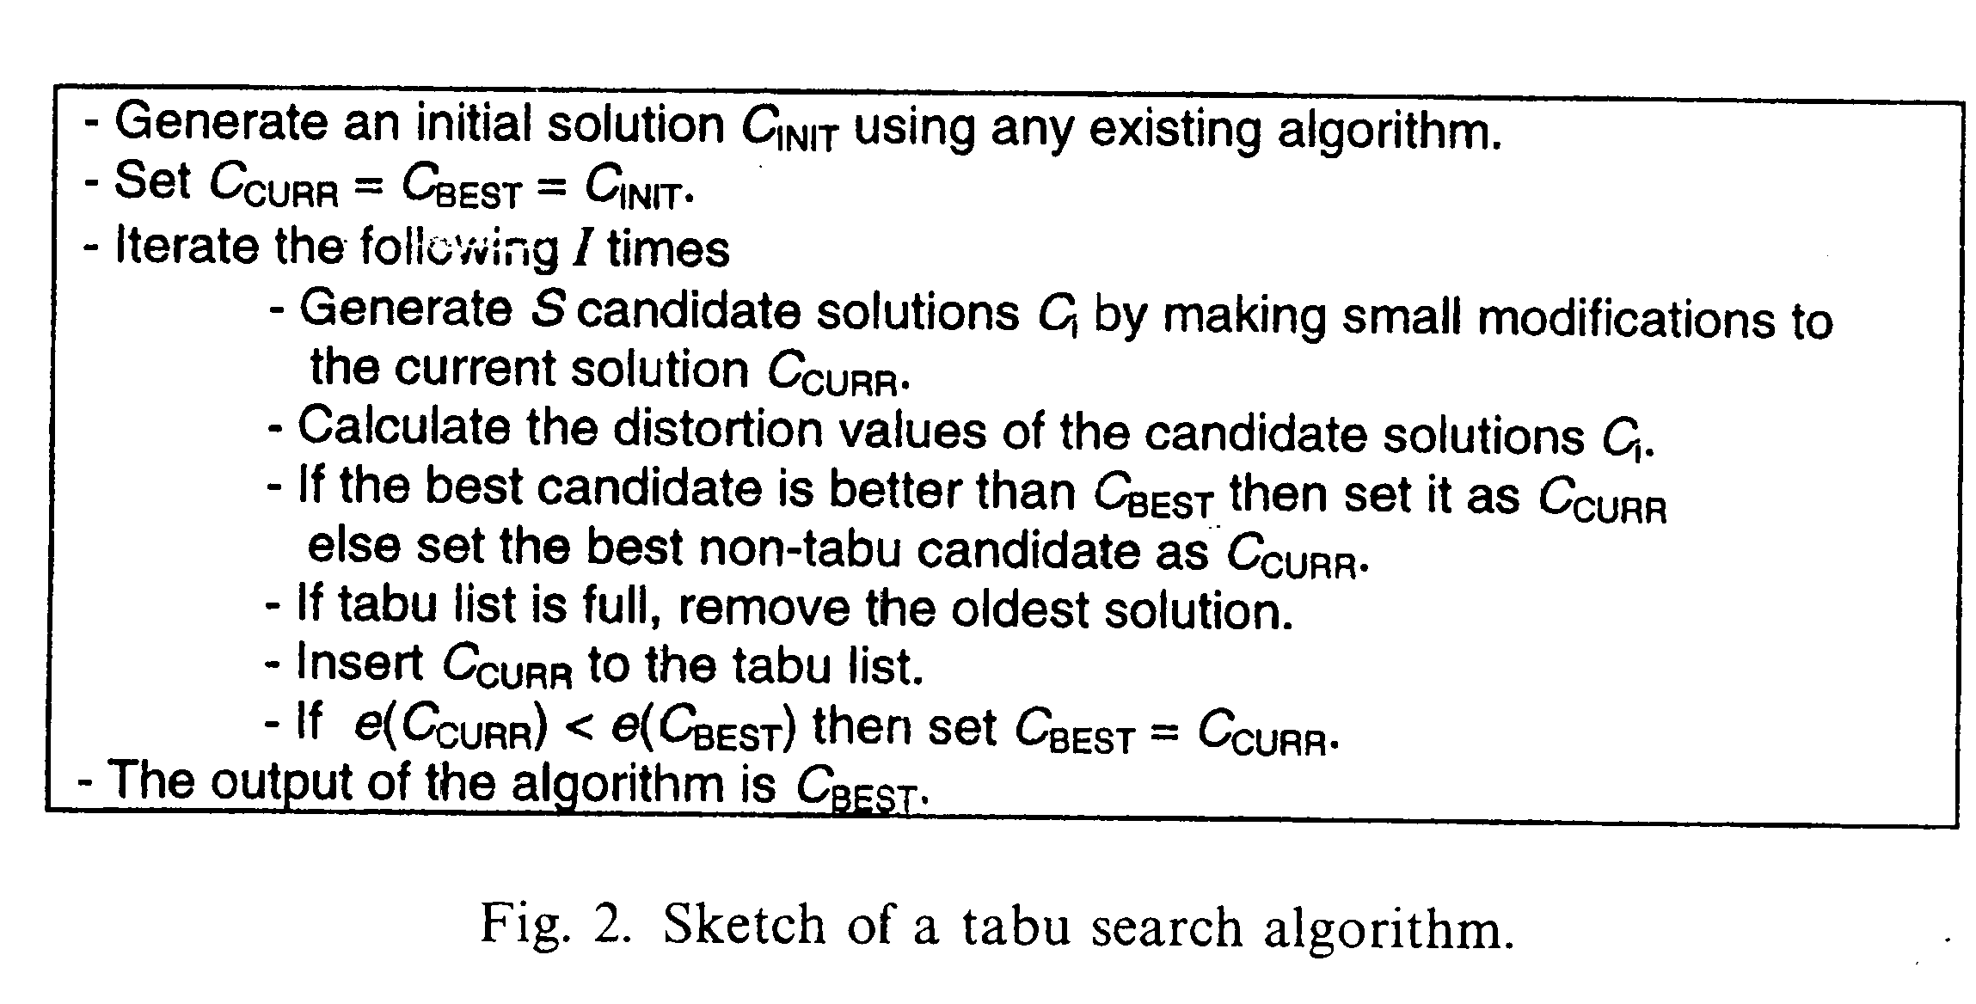
A typical VQ data set has the following properties:
• A large number of training vectors in the source data (N).
• High dimensionality of the data set (K).
• Relatively large number of clusters to be formed (M).

3.1 Representation of a solution
• codebook-based (CB)
• partitioning-based (PB)

3.2 Selection of the parameter values
The four main parameters of the tabu search algorithm are: probability threshold for the changes, the umber of iterations, the number of candidate solutions and the size of tabu list.

3.3 Definition of neighboring solution

3.4 Inclusion of GLA iterations
This modification has at least three potential improvements:
- the search space is greatly reduced;
- only reasonable solutions will ever be considered;
- tabu list may become effective after all.

3.5 The use of tabu list
A candidate solution declared tabu if an identical solution is found in tabu list.

- Comparison with Existing Algorithm
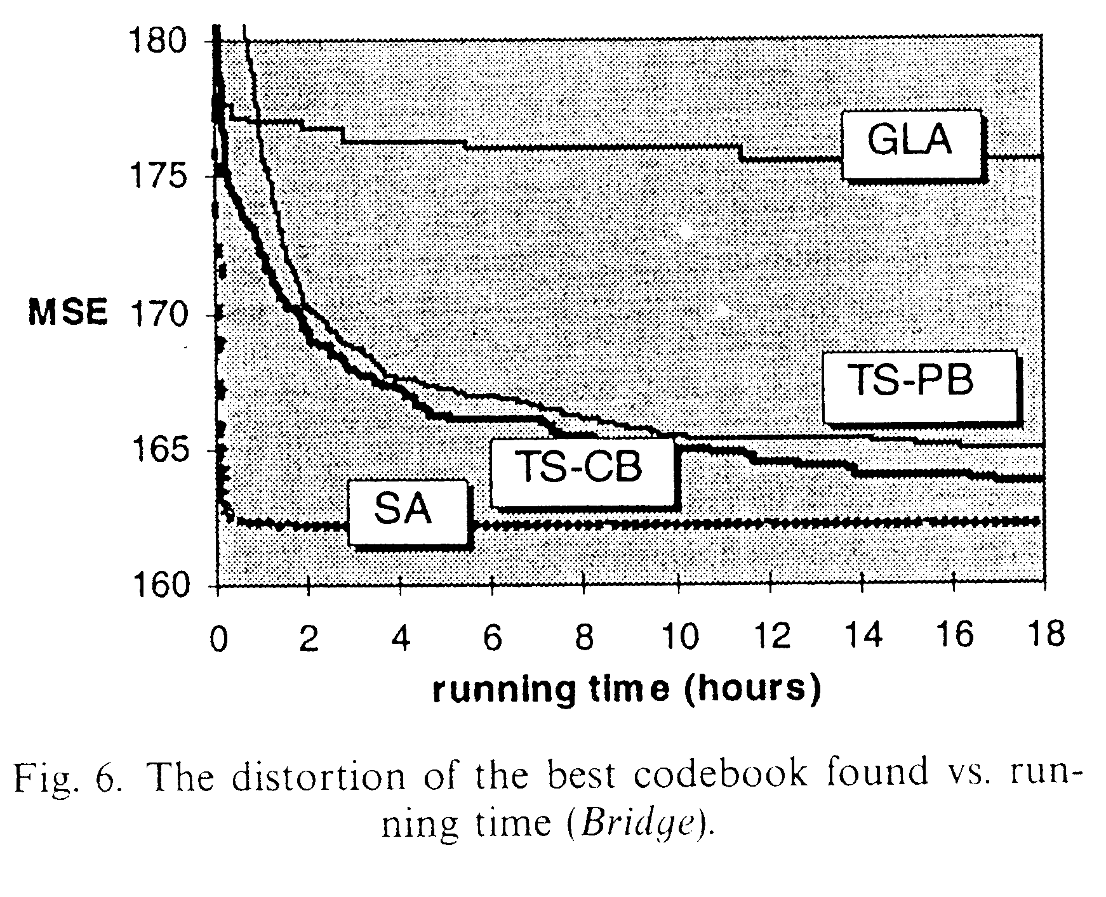

- Conclusion
The MSE-values were 20% lower than those of GLA on average. For gray-scale images, simulated annealing was slightly better (2-5%). The main drawback of the proposed algorithm is the high running time.

Created by: Chia-Hao Yang
Date: February 2, 1999

